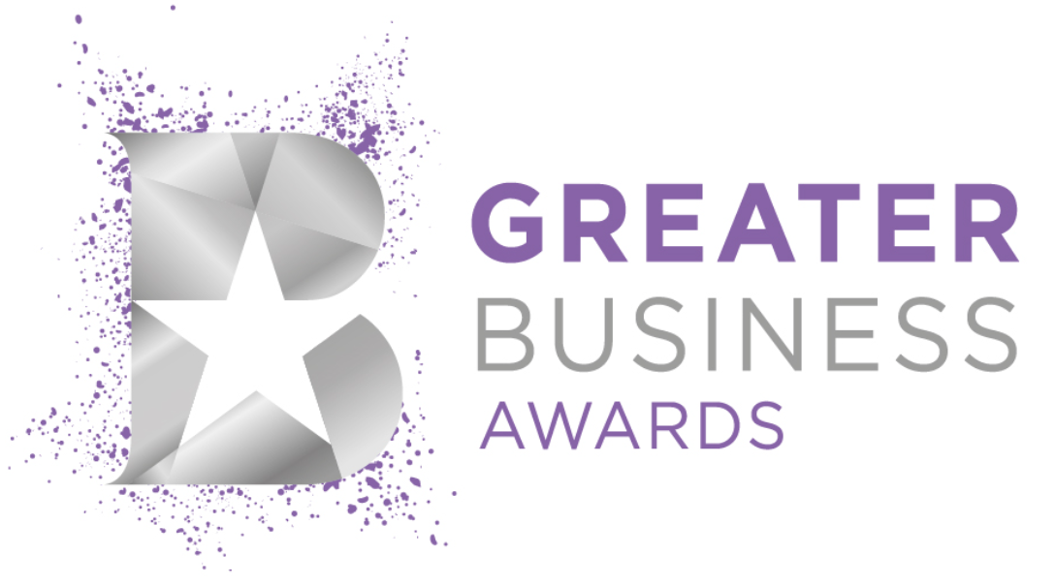

Greater Business Awards 2027:

Be the Best in Solihull

Contents

1. Category Breakdown 1
2. Eligibility Criteria 2
3. Application Form & Questions 4
Part A: General Questions 4
Part B: Application Questions & Scoring 5
Business Ambassador Award Application & Scoring 6

Category Breakdown

Not sure which award to apply for? Please see below for a breakdown of each category:

Breakthrough Business 2027 (Start-up / SME of the year)
This award celebrates start-ups and SMEs who demonstrate exceptional achievements, have overcome obstacles and/or risen to business challenges. Applicable to those that have started a business within the last 2 years, or with no more than 40 employees.

Business Ambassador 2027 (Outstanding contribution)
This award celebrates individuals who make an outstanding contribution beyond their own organisation, championing their business community, sector or place. It recognises leaders who inspire others, create opportunities and make a lasting positive impact through advocacy, collaboration and leadership.

Business without Borders 2027 (Excellence in International Business)
This award is open to businesses who have demonstrated excellence in international business, navigating the complexities of international markets to achieve success and support their business’ growth.
Community Builder 2027 (Excellence in contribution to community)
This award celebrates contribution to the community, and is aimed at businesses going above and beyond to make a committed and proactive contribution to the enhancement and benefit of their community. It recognises businesses prioritising their Corporate Social Responsibility (CSR) practices.

Customer Commitment Award 2027 (Excellence in customer service, hospitality, retail, events and professional services)
This award is open to businesses that have provided exemplary service, value, expertise and impact to customers; businesses that have made exceptional contributions in this area, exceeding normal expectations, and delivered outstanding quality service to their customers, in a way that sets them apart from their competitors. It includes service industries, professional services, consultants, agencies, hospitality and retail establishments, events companies, and suppliers, and is open to both bricks-and-mortar and online businesses.

Digital Revolutionary 2027 (Excellence in Technology & Digital)
This award celebrates businesses in any sector who demonstrate excellence in technical innovation, application development and design. It recognises organisations that are pioneering new ways of working, embracing cutting-edge technologies, and creating digital solutions that make a real difference. We are looking for businesses that think differently, solve challenges creatively, and lead the way in their industry through technology.

Influencer 2027 (Excellence in PR, Media, Marketing)
This award recognises the achievements in supporting the growth and visibility of the business, and covers sales, marketing, digital media, events, PR and other communication roles either in-house or within a specialist agency.
Non-Profit Champion 2027 (Excellence in third sector)
This award celebrates excellence in the third-sector. It is open to and includes charities, voluntary and community groups, social and creative enterprises and cooperative organisations who have made a significant contribution and impact across Solihull through social, environmental and community initiatives.

Pioneer 2027 (Excellence in innovation)
This award is applicable to those in any sector who have created innovative solutions through their work, to positively impact delivery, performance or customer experience. This award is open to organisations and leaders who think outside the box, challenge the norm and bring fresh ideas to life and shining a light on those who are pioneering progress and setting new standards in their field.

Sustainability Trailblazer 2027 (Excellence in sustainability)
This award is for any business which are successfully addressing environmental challenges through innovative and sustainable practices and/or projects, and demonstrating a commitment to change.

Workplace Champion 2027 (internally focused inc. people development, health & wellbeing, D&I in the workplace)
This award celebrates businesses or individuals who have made a difference in their workplace. From providing training and mentoring, to supporting wellbeing and EDI, this award recognises those who have gone above and beyond to build a positive culture in their organisation.

Eligibility Criteria

- Applications are open to all members of the Solihull Chamber and/or businesses who trade within the following postcode areas: B26, B27, B28, B36, B37, B40, B46, B90, B91, B92, B93, B94, CV4, CV5, CV7, CV8.
- If you are a Solihull Chamber member but are based outside of the region, then you are eligible to enter any of the categories but will not be eligible to win the overall ‘Business of the year’ award.

- If you are not a member of the Greater Birmingham Chambers of Commerce, you are eligible to enter any of the categories but will not be eligible to win the overall ‘Business of the year’ award.

- Each organisation may apply for a maximum of two categories.

- The Business Ambassador category is open to individuals only. Applicants may nominate themselves or someone they know.

- There are no restrictions on previous applicants or winners entering the 2027 awards.

- The awards are free to enter.

- When reviewing nominations, GBCC will consider any publicly available information, including if the nominee has been or is involved in any legal, regulatory, or reputational matters.

- If an organisation sponsors a category, it is not able to submit an application for that category. However, it may submit an application for other categories.

Application Form & Questions
Applications may only be made using the online portal.

Part A: General Questions
The following questions will be asked on the portal as an overview of your organisation:
Contact name (first name, surname)
Company name (please ensure this is typed as you would like it publicised)
Company address
Email address
Website address
Contact number
Social media handles/URL
Business sector
Nature of business
Main product/service
Number of employees
Who are typically your customers?
Legal Status of company
What year did the business start trading?
Is your business a Chamber member in the Greater Birmingham area (any division)?
Company logo (jpeg or png format)

Part B: Application Questions & Scoring
The following questions will be asked for all categories except the Business Ambassador Award:

QUESTION 1
Tell us about your organisation over the last 12 months. (Max 200 words; 30 marks.)
Marks will be awarded for clarity (10 marks), success & achievements (10 marks), commitment to or engagement with region (10 marks.)
Judges will be looking for;
- Business objectives and priorities
- Your engagement with, or commitment to, the Solihull area
- General examples of business success over the past 12 months such as growth in turnover

QUESTION 2
Tell us why your organisation deserves to win your chosen award. (Max 500 words; 70 marks.)
Marks will be awarded for clarity (10 marks), actions & achievements (20 marks), evidence & impact (20 marks), impact in region (20 marks.)
Judges will be looking for;
- Examples directly relevant to your chosen category
- A track record of achievement or impact connected to your chosen category
- Consider how the achievements can be independently verified, if needed

Business Ambassador Award Application & Scoring
The questions for the Business Ambassador Award are slightly different to the above.

QUESTION 1

Tell us about the nominated individual over the last 12 months. (Max 200 words; 30 marks)

Marks will be awarded for clarity (10 marks), success & achievements (10 marks), commitment to or engagement with region (10 marks.)

Judges will be looking for:

- An introduction to the nominated individual, including their role, organisation and area of influence
- Your relationship to the nominated individual
- Examples of how the nominee has championed their business community, sector, profession or place over the past 12 months
- Engagement with, or commitment to, the Solihull area

QUESTION 2

Tell us why this individual deserves to win this award (Max 500 words; 70 marks.)

Marks will be awarded for clarity (10 marks), leadership & collaboration (15 marks), change & impact (15 marks), evidence (15 marks), impact in region (15 marks.)

Judges will be looking for:

- Examples directly relevant to chosen category
- A track record of achievement or impact connected to chosen category
- Evidence of the nominee's impact beyond their own organisation, such as advocacy, collaboration, mentoring, thought leadership or creating opportunities for others
- How they stand out in the Solihull area.

