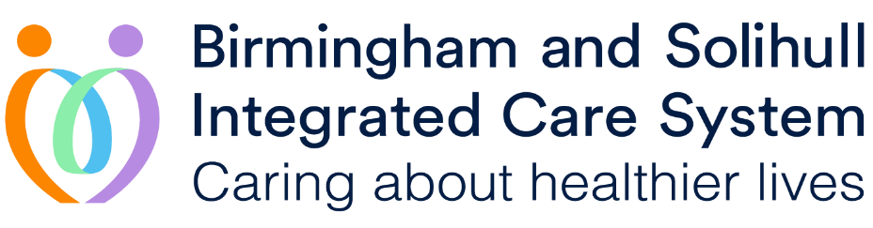

Fairer Futures Fund

Expressions of Interest:
Market Engagement

- Background
- Priorities and Outcomes
- Solihull Principles for use of the Fund
- Market engagement
- Your Initial Idea

Please Note: Any commercially sensitive information supplied by providers will be stored confidentially and will not be disclosed to any third party


- Background

Introduction
The Fairer Futures Fund (FFF) is a mechanism to support the Birmingham & Solihull (BSol) Integrated Care System to move to new ways of working that bring teams together to think, plan and deliver in a different way. The Integrated Care Board has delegated responsibility for the allocation and management of the fund to the Place Committees to administer in line with the needs of local residents.

The fund is designed to seed-corn and support activities that will contribute to improved integrated working which in turn will improve outcomes and help to tackle inequality. Initially, the majority of these may be on a very localised or team-based level, with a view to some initiatives creating new ways of working that can be scaled up and adopted across Birmingham and Solihull.

The Place Committee
The Place Committee is a formal subcommittee of the Integrated Care Board (ICB) to formalise place working and to delegate responsibility and control of functions and budgets.

The functions are:
- Provide community leadership and engagement
- Commissioning powers for community services
- Joint responsibility with the ICB for delivering Primary Care Strategy
- Responsibility for determining the local outcomes they expect the whole system to deliver on behalf of the communities they serve
- Joint responsibility with ICB for the distribution of the Fairer Futures Fund

Membership includes Chief Executive, Solihull MBC (Chair), ICB Executive leads, Community Integrator rep, Primary Care Provider rep, NHS community service rep, Public Health, Adult Social Care, Childrens Social Care, VCSE, Healthwatch, Police and Solihull Community Housing.

The Funding
The funding has been split on a fair shares basis between Birmingham and Solihull, with Birmingham receiving £18m and Solihull receiving £4.2m for the next 3 years. Spend is at the discretion of each Place Committee and the vast majority (if not all) of the funding will be specific to that place. There is also £3m to support the reduction of Health Inequalities across the BSol system although there is an expectation that plans at system level will complement plans at place.

Purpose
The purpose of the fund is to:
- Bring teams and organisations together to think, plan and deliver in a different way;
- Support the core purpose of the ICS – improve outcomes, reduce inequalities, enhance value for money and support broader social and economic development;
- Support the Leadership Transformation Priorities – Integrated Neighbourhood Teams, technology, workforce, estates, inequalities, and using excellence to standardise care;
- Deliver against the Solihull Outcomes Framework (see below).

The Fund is not intended to be used to standardise existing delivery models or plug funding gaps in existing services.

Why Market Engagement?
The Solihull Place Committee want to engage with the market to determine expressions of interest at this stage. This market engagement provides the opportunity for organisations based in Solihull to specify their interest in delivering services in Solihull aligned to this EOI. It should be noted that at this stage this is not a procurement/tender exercise. Following the closure of this EOI stage, submissions will be reviewed and key points of feedback shared with the Place Committee. The formal procurement process will then begin and individuals who have submitted Expressions of Interest will be able to submit formal applications. Formal applications will require registration with CSW Jets (please see attached documentation). Please see timeline below for further information regarding dates.
Anticipated Process/Timescales*
Market testing sent out: | 24th June 2023
Deadline for return from providers: | 9th July 2023
Procurement Process begins: | 7th August 2023
Deadline for return of proposals | 24th September 2023
Funding Awarded | 8th November 2023
*Subject to change
Completing Questionnaires
As noted above, the Solihull Place Committee would be grateful if you could complete the ‘Market Engagement’ and ‘Your initial idea’ sections and respond by 9th July 2023.

- Priorities and Outcomes

FFF projects will be expected to align to the local priorities to improve outcomes and reduce health inequalities, as set by the Place Committee.

- Establishing a Community Integrator focusing on community improvements, in particular, integrated urgent care services, support for people with Long Term Conditions, Home First, and a focus on prevention and early intervention.
- Establishing an integrated ‘Prevention and Early Help’ model, including family hubs
- Mental health including 6 priorities around prevention, children and young people, maternity and parenting, primary care support, crisis support and rehabilitation

- Solihull Principles for use of the Fund

* Link to Solihull Health Inequalities Strategy - Tackling health inequalities in Solihull 2022- 2025

In addition, the Fund will be allocated and managed fairly with particular reference to:
- Impartiality and transparency in decision-making by the Place Committee;
- Objectivity in evaluating projects;
- Projects to be informed by expertise of practitioners, as well as communities;
- Co-production and equal partnership with the voluntary sector and communities.

Projects will also be expected to contribute to the following outcomes as set out in the Solihull Outcomes Framework

Wider determinants
- More children will be ready for school when they start
- More people adopt a healthy lifestyle
- More people are in well paid work
- People live in an environment (physical and social) which supports their health and wellbeing
Outcomes for people
- Level up life expectancy
- More people have good mental health
- More people live independently for longer
Our services
- People with additional needs experience care and support that helps them recover and maximise their independence
- Our health and care services
- Deliver good quality care and support to the population
- Our services work together to have a positive impact on outcomes and reduce health inequalities

- Market Engagement

Name of Organisation:
Contact Name & Role:
Address:
Tel. No:
Email:

- Your Initial Idea

Please keep to a maximum of 200 words per question

- Please provide an outline of your initial idea – what will be delivered including brief outline of outputs and outcomes?

- How would your proposal meet the criteria that is outlined, including improving outcomes and reducing health inequalities?

- What else should we consider that is not in the existing criteria?

- Who is your project aimed at and why?

- What is the evidence base for your project?

- Who is the lead accountable body and who are the delivery partners?

- How will you co-produce your formal proposal with partners?

- How will you involve the community in developing the proposal?

- How much funding will you require?

- What programme of work does the proposal link to? (e.g., Community Integrator, Prevention, Mental Health, other)

We would value any further comments/views on our proposed approach to allocation of the FFF

Please email your response to the Solihull Council Fairer Futures Fund contact address at FFF@solihull.gov.uk by 9th July 2023.

