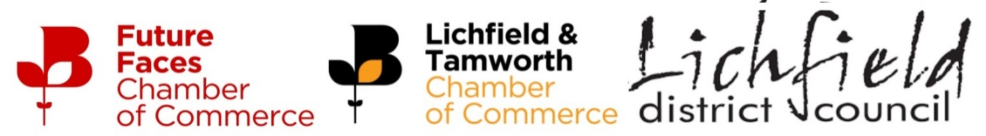
Lichfield District Council-Funded Future Faces Chamber of Commerce Membership
Application Form

If you wish to apply for a fully funded Future Faces Chamber of Commerce Membership for 2024 please fill in information below and send to Division Director, Chris Brewerton at c.brewerton@birmingham-chamber.com
Your 150 word profile will tell us about what you do in your role and will be used to judge the applications if we receive over the 10 memberships being funded by Lichfield District Council.
For more information on the Future Faces Chamber of Commerce please see link HERE
Name
Company Name
Job Title
Business Address
Post Code
150 Word Profile

Terms and Conditions
You must be aged no older than 35 years on 1st February 2024 to apply for a funded Future Faces membership
The young professional must be employed by a business with an office within the Lichfield District Council boundary (see map HERE) and the site must be their primary location of work.
Applications from young professionals who work from home in the area but who’s primary location of work is outside of the Lichfield area will not be considered.
The Future Faces membership will last for 12 months from the date of confirmation in 2024, upon renewal the membership will need to be funded by the young professional or the company they work for, the renewed membership will cost £150+VAT per annum
If more than 10 applications are received the Lichfield and Tamworth Chamber Executive Committee will meet to decide on the most suitable 10 applicants based on the 150 word profile submitted, the judge’s decision is final and no discussion will be entered into regarding feedback on the applications.

